Business Assignment

Author
Institutional Affiliation
Instructor
Course code
Date of submission

Chipotle Mexican Grill Inc. is a Mexican fast-casual restaurant engaging in the Mexican food business throughout the United States. The company, founded by Steve Ells in 1993, is headquartered in Newport Beach, CA (Chakravarty, 2018). The Company has an observably good and effective business alignment between the business model and the operating model. Chipotle engages in quick-service restaurants and creates value for the consumers by offering them quality food, a clean dining environment, and efficient services. It is argued that the business model adopted by the company is observably effective since it resonates well with middle-class consumers. Arguably, this has made Chipotle stand out among its competitors.
A closer analysis of the conventional features of the fast-food industry reveals that many operational features of the company run against the conventional wisdom in the fast-food industry. The fast and high-quality perspectives adopted by the company have helped the Chipotle brand to maintain observably high consumer turnout rates throughout its stores countrywide. With no freezers, all Chipotle stores engage in the production of high-quality fresh food which presents the consumers with a distinctly different taste from that of the competitors in the industry. Even though competitors such as Taco Bell in the same industry offer their consumers value-based additions and promotions, Chipotle brand operates on an observably uncommon strategy with premium pricing that the customers are always willing to pay because of the quality food (Abwanzo, 2017).
Chipotle's menu remains very simple and focused. Despite the recommendations from McDonald, which was once one of Chipotle's big shareholder, Chipotle refused to serve "low-risk high-profit items", such as coffee and cookies, because they do not fit with their signature dining experience. The chipotle brand has for a long time focused on the idea of food with integrity. Notably, the company devotes itself to make the best food products with the very best ingredients.
Recently, the company brand began to devise ways through which to increase its revenues by re-envisioning its purpose to change the way people think and eat their food. Moving forward Chipotle focuses on diversifying its consumer base. Even though the American market generates enough profits for the company, overdependence on this single market is actually a threat to the meaningful existence of the company (Ho et al., 2014).
Currently, Chipotle has only a small number of restaurants outside the United States. The company operates over 3000 stores and only 37 of these operate in the international market. Arguably, this is a weakness in the sense that the company has failed to utilize the opportunity of expanding its brand globally and has instead focused only on the local market. The local US market presents the company with various problems some of which include; a limited number of suppliers. Chipotle Mexican Grill depends upon a limited number of suppliers for its main ingredients such as chicken, pork and beef. The local market is observably saturated with a lot of competitors and this may result in the supply of low-quality products. For instance, in 2015, due to limited supplies, Chipotle encountered major controversies some of which included the outbreak of E. Coli infections (Simpson, 2015).
The current competitive market in the US presents a severe threat to the company. The other competitor brands in this market are constantly pushing forward by improving their services and bringing in new menus. For this reason, Chipotle seems threatened if they will remain to consider the local market as their source of revenue. Research evidence shows that single markets are always riddled with untold uncertainties that might significantly affect a particular business’ abilities to achieve its goals. Additionally, because of the existing rules and regulations in a single market, issues of fractional and incomplete liberalization in single markets are likely to reduce the potential gains of companies that place depend so much on them.
The company’s key strategy at the moment is to focus on the establishment of an international brand by creating new extensions in the international market. The company focuses on a differentiation strategy that involves offering new products in observably new markets. Believably, this strategy would help the company keep up with the ever-increasing competition in the food industry. For instance, because of limited supplies of quality ingredients in the local US market, Chipotle has continually failed short of their reasonably raised expectations to offer quality. This is because they are not able to get supplies in good time. It is projected that such occurrences might result in significant reductions in revenues in the coming years.
Chipotle competes with major brands such as McDonald's, Wendy’s and Pizza Hut among others in the fast-food industry. As a Mexican company, it is essential to note that Mexican foods only account for 8 % of the overall market while burger and chicken account for over half of the market share (Thompson, 2019). In this sense, globalization seems to be an effective idea if the profits and the revenue margins are to be maintained.
The diversification process by Chipotle indicates that the company is planning to enter the Burger segment for its global market where they have already launched two Chipotle Restaurant chains with many locations, they include The Asian ShopHouse and Pizzeria Locale. Therefore, Chipotle company believes that their model can work for a variety of food styles that were popularly impacted by the noro-and e Coli scandal and the company are off sharply. The company slogan "food with integrity" also promises and also gives its diversification through a combination of a healthy menu item, attractiveness, overtime and diners which are likely to get back. And also branded restaurant chains help in generating additional revenue streams to companies which will also help Chipotle in the long term run.
The global expansion of Chipotle come across its 2,452 restaurants in the U.S. and other 37 international location making its spread globally. The company solves the SWOT weaknesses of the rise in price for some items which had led to the loss of customers to the company thus making the company factor the price for the sustainability of customers and also curb high competition. In addition, to solve the problems the company also intends to add newer product for their effort not to be left behind thus promoting growth.
The growth of the company has been affected by various outbreaks of foodborne illness that occurred in the U.S. a few years ago where the stock decreased by half. This is the reason why the company is intending to get into the global market to reduce such occurrence of countries outbreaks. It is a decision that is planned to reach the out market for the company globally. Different market in different nations also will give the company an opportunity to recruit more employees from different nations for the expansion of the market to their restaurant.
Transparency is another factor that is intended to boost the global market for the company. Also, the research of the market shows that the global fast-food market is estimated to reach more than $600 billion motivated by the demand from Asia. Chipotle is also planning to grow their business in Europe since they have been dealing with their business within the U.S. mostly in Canada. This expansion and the global market is targeted to win the market completion through their winning strategies of serving quality food and also factoring out the price of food thus attracting more customers.

Chipotle is also expected to meet the cultural obstacle of a restaurant in European countries that are not familiar with Mexican food. Due to the global market and competition, the company is expected to adapt to the cultural food from the European countries and also carry out research for the type of favourable food to them. For the company to win more customers in the European countries they need to adapt to their culture and also prepare food that is favourable to western people. Also, on the acceptance of the food to the western people, Chipotle need to educate them to get an understanding of their product, market, enticing them and also recommending their product to others (Thompson, 2019).
With the experience, chipotle had of market completion in the year 1990 with the launching of London three stores that led to the closing of Mexican food which was losing consumers. Chipotle closed their business due to lack of profit, therefore with the experience they had, intended to invest extensive customers for different scenarios y considering and also implementing a change of menu and ingredients. They also intend to use future content of media, messaging and innovation strategies that will allow customers also to participate in the business and give chipotle a chance to bring in a new product with the change of time. Chipotle need to allow innovation and the use of media to advertise for their product-market them and also make change and order through the use of media where they will use the observation made from the previous scenarios in the UK.
Branding of products also is another strategy for marketing and making Chipotle’s products more valuable, attractive and marketable across the world (Plowman, 2019). Like in the U.S. the food was marketable due to the Mexican immigrants who were in the area compared to Europe where there were fewer Mexican immigrants.

This needed them to bland and market their product so that they can gain more customers globally as it is in the U.S. Technique on which to be used in the processing and eating method of the Mexican food was also another factor. This was facilitated by the geographical location of the area which gave them easier access.
Also, to address the commercial concern, Chipotle is expected to use localization tactics for its international expansion. Initially, they went from modification of prices and slogans to the actual ingredients and presentation of the menu to customers which made their company expand due to their services. To expand their company globally they too intend to advance their model of modifying prices and slogans and presenting the menu to the customers which will make customers enjoy their services and be more attracted.
On the other hand, for the attractiveness of their restaurant, Chipotle needs to have a huge and beautiful building in all their business that will attract customers even from far. Architectural composition is one of the strategies to win more customers through having an attractive and tall building. The tall building also has the advantage of giving privacy to customers and also reducing congestions in the restaurant (Abwanzo, 2017). Customers are also attracted to a tall building for the aerial viewpoint while they are having their meal in the restaurants, thus Chipotle needs to factor out the size of the building.
Chipotle also intend to perform online sales as it intends to go globally. Online sales help the company in teaching their customer who are also in their working areas or at home where they can make an order online or check for preferred food online instead of visiting the restaurant. This is another international expansion strategy the company has executed and intends to perform through its international locations.
For instance, during the pandemic, the company will be able to open a room for online sales where all customers are served following the health protocols. These will allow the reopening of new locations thus bringing good margins of demand.
Finally, as Chipotle is going into the global market, they need to change of his food names in order to get market in European countries. Due to the culture and environment, they need to change the names of the food for them to accommodate all customers according to the taste of their preferred name according to the area. Also, on the changing of the names, they too need to adopt the culture of the western countries for them to acquire more customers. And finally, they need to adjust their prices according to the European nations in order to accommodate more customers and compete with others on their market (Simpson, 2015). And also, to enjoy more profit they need to have more strategies of advertising their product and also translating to customers who do not understand the language.
Future trends
Currently, Chipotle is planning on building its brand through globalization besides the improvement of the current restaurants and the addition of new ones in a bid to initiate a new return to effective competition. Chipotle’s current share price is 381.07 dollars. Based on this valuation, the price target is 175.11 dollars. Looking forward, Chipotle is expected to continue struggling to improve its profit margins. With the added establishments, Chipotle is expected to make significant strides in the global fast foods industry. Currently, this remains to be one of the biggest areas of growth for the brand in the next coming years. In comparison, it is evident that Chipotle is performing well with significant positive trends over the past 3 years.
Believably, this is what is expected in the next coming years because of the continued consumer trust. Financial analysis however reveals that major brands such as Wendy’s, McDonald's and Yum brands are still way above Chipotle, the expected profit margins are still attractive for the company.
With this diversification strategy, Chipotle’s growth rate is projected to stand at 4.36% in the next three years. The new global stores on average would generate 75% of the sales compared to the existing stores. It is of great importance to know how sensitive the target prices are to the expected changes. Sensitivity analysis done by adjusting the discount rate and the revenue growth reveals that the target price would only be justified if the discount rates remain at the 7% level. This is an indication of the fact that the model is pretty sensitive to the assumptions. Because the diversion idea is expected to excite investors, the revenue and sales are projected an all-time high in the next coming years. Observably, following the infection outbreak, the Chipotle brand has since built its loyal following with a projected increase in customer purchase by almost 7 %.
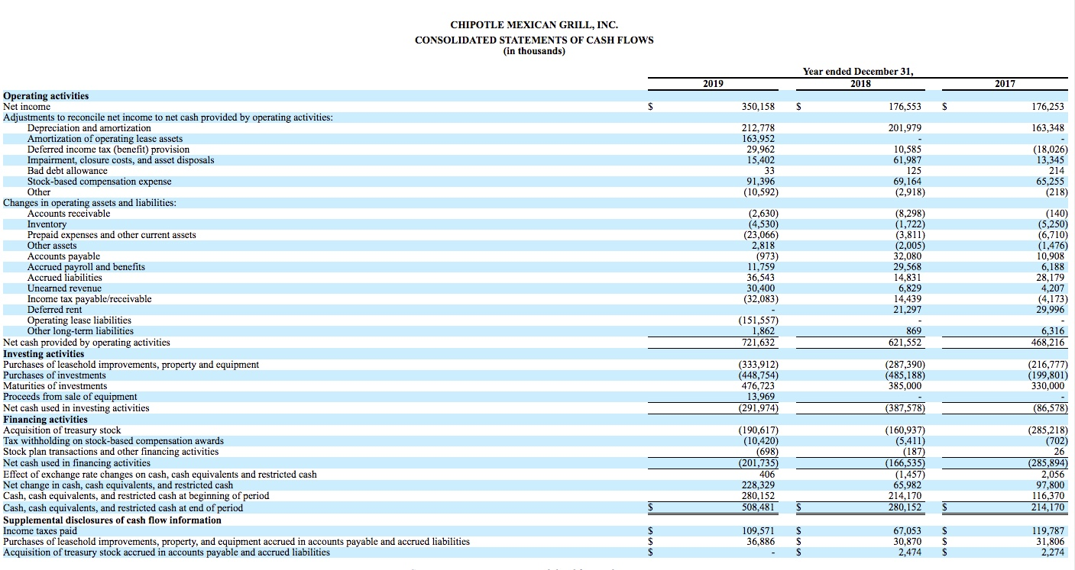
References
Abwanzo, B. (2017). Chipotle Company Assessment. Available at SSRN 3278492.
Chakravarty, A. Chipotle Mexican Grill From the Plate to our Stomach, the Mexican Way.
Gilliard, D. J., Hoffman, D. L., & Baalbaki, S. (2017). Is chipotle Mexican grill successfully recovering from its food-related incidents?. Journal of Marketing Development and Competitiveness, 11(4), 34-48.
Plowman, S. (2019). A Strategic Audit of Chipotle Mexican Grill, Inc.
Simpson, S. (2015). Chipotle Mexican Grill Inc.: Strategy with a Higher Mission or Farmed and Dangerous?. Journal of Case Studies, 33(2), 38.
Thompson, A. A. (2019). Chipotle Mexican Grill’s Strategy in 2018: Will the New CEO Be Able to Rebuild Customer Trust and Revive Sales Growth?.
Understanding Chipotle's Financials (CMG). Investopedia. (2021). Retrieved 23 June 2021, from https://www.investopedia.com/articles/markets/020116/understanding-chipotles-financials-cmg.asp.

